LUCY HUANG
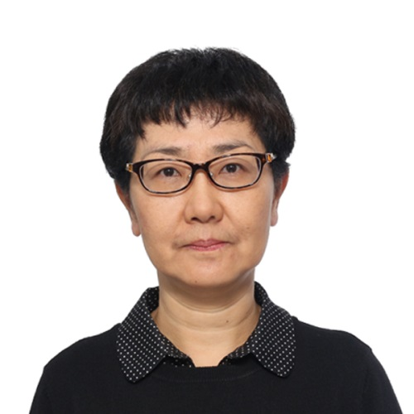

Honorary Treasurer

I am a Senior Lecturer and Chairperson of Staff-Student Committee in the Department of Geography and Resource Management, Lady Warden in Hostel II, a Member of Student Hostel Management Committee and a Member of General Education Committee, Shaw College, the Chinese University of Hong Kong. I got my BSc degree from Shanghai Teachers' University, MSc degree from East China Normal University and PhD degree from the Chinese University of Hong Kong. My teaching and research areas include urban and regional development, spatial analysis and quantitative geography. I am a member of Hong Kong Geographical Association and a member of the Geographical Association of China. I am the Secretary-General of the Speciality Committee on Quantitative Geography of Geographical Association of China and a Correspondent Member of the Commission on Modelling Geographical Systems, International Geographical Union. I have published in following international journals: Urban Geography, Journal of Geographical Systems, International Development Planning Review, Asian Geographer, World Regional Studies and The Journal of Chinese Geography.

